Reaching BVICAM
From | Distance (Km) (Approx.) | Information
Airport (Terminal 1D) | 16 | Taxi Fare | Rs. 230
Airport (Terminal 1D) | 16 | Auto Fare | Rs. 135
Airport (Terminal 1D) | 16 | Bus Routes | -
Airport (Terminal 3) | 25 | Taxi Fare | Rs. 360
Airport (Terminal 3) | 25 | Auto Fare | Rs. 210
Airport (Terminal 3) | 25 | Bus Routes | 947
New Delhi Railway Station | 17 | Taxi Fare | Rs. 240
New Delhi Railway Station | 17 | Auto Fare | Rs. 140
New Delhi Railway Station | 17 | Bus Routes | 917, 918, 949, 954
New Delhi Railway Station | 17 | Metro Route | NEW DELHI -->CHAWRI BAZAR -->CHANDNI CHOWK -->KASHMERE GATE (Junction) <Change Train Here> -->TIS HAZARI -->PUL BANGASH -->PRATAP NAGAR -->SHASTRI NAGAR -->INDER LOK (Junction) <Change Train Here> -->ASHOK PARK MAIN (Junction) -->PUNJABI BAGH -->SHIVAJI PARK -->MADI PUR -->PASCHIM VIHAR (EAST)
Old Delhi Railway Station | 16 | Taxi Fare | Rs. 230
Old Delhi Railway Station | 16 | Auto Fare | Rs. 135
Old Delhi Railway Station | 16 | Bus Routes | 926, 929, 939
Old Delhi Railway Station | 16 | Metro Route | CHANDNI CHOWK -->KASHMERE GATE (Junction) <Change Train Here> -->TIS HAZARI -->PUL BANGASH -->PRATAP NAGAR -->SHASTRI NAGAR -->INDER LOK (Junction) <Change Train Here> -->ASHOK PARK MAIN (Junction) -->PUNJABI BAGH -->SHIVAJI PARK -->MADI PUR -->PASCHIM VIHAR (EAST)
Hazrat Nizamuddin Railway Station | 22 | Taxi Fare | Rs. 320
Hazrat Nizamuddin Railway Station | 22 | Auto Fare | Rs. 180
Hazrat Nizamuddin Railway Station | 22 | Bus Routes | 966
ISBT (Kashmere Gate) | 16 | Taxi Fare | Rs. 230
ISBT (Kashmere Gate) | 16 | Auto Fare | Rs. 135
ISBT (Kashmere Gate) | 16 | Bus Routes | 926, 929
ISBT (Kashmere Gate) | 16 | Metro Route | KASHMERE GATE (Junction) -->TIS HAZARI -->PUL BANGASH -->PRATAP NAGAR -->SHASTRI NAGAR -->INDER LOK (Junction) <Change Train Here> -->ASHOK PARK MAIN (Junction) -->PUNJABI BAGH -->SHIVAJI PARK -->MADI PUR -->PASCHIM VIHAR (EAST)
ISBT (Anand Vihar) |  | Taxi Fare | Rs. 410
ISBT (Anand Vihar) | 29 | Auto Fare | Rs. 240
ISBT (Anand Vihar) | 29 | Bus Routes | 939
ISBT (Anand Vihar) | 29 | Metro Route | ANAND VIHAR -->KARKAR DUMA -->PREET VIHAR -->NIRMAN VIHAR -->LAXMI NAGAR -->YAMUNA BANK (Junction) -->INDRAPRASTHA -->PRAGATI MAIDAN -->MANDI HOUSE -->BARAKHAMBA -->RAJIV CHOWK (Junction) -->RK ASHRAM MARG -->JHANDEWALAN -->KAROL BAGH -->RAJENDRA PLACE -->PATEL NAGAR -->SHADIPUR -->KIRTI NAGAR (Junction) <Change Train Here> -->SATGURU RAM SINGH MARG -->ASHOK PARK MAIN (Junction) <Change Train Here> -->PUNJABI BAGH -->SHIVAJI PARK -->MADI PUR -->PASCHIM VIHAR (EAST)

Visit on http://www.delhimetrorail.com/zoom-route-map.aspx for Delhi Metro route details
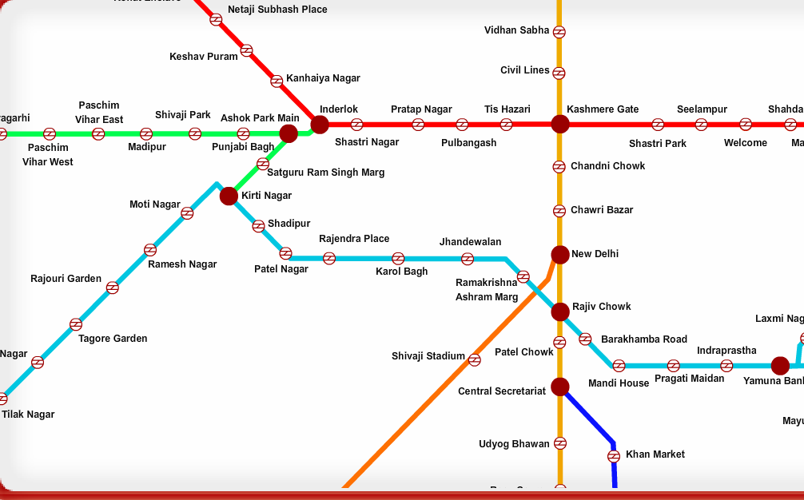
The Institute is located next to Paschim Vihar (E) Metro Station. The following map will help you in reaching the venue:
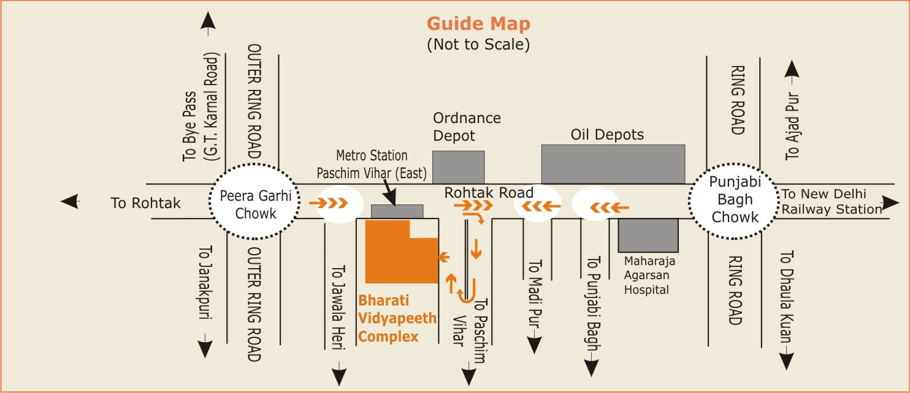
The complete address is as under:
Bharati Vidyapeeth's
Institute of Computer Applications and Management (BVICAM),
A-4, Paschim Vihar, Opposite Ordnance Depot, Paschim Vihar (E) Metro Station,
Main Rohtak Road, National Highway 10, New Delhi-63.

